UX Check Results

# Heuristic: Error prevention

# Severity: 2

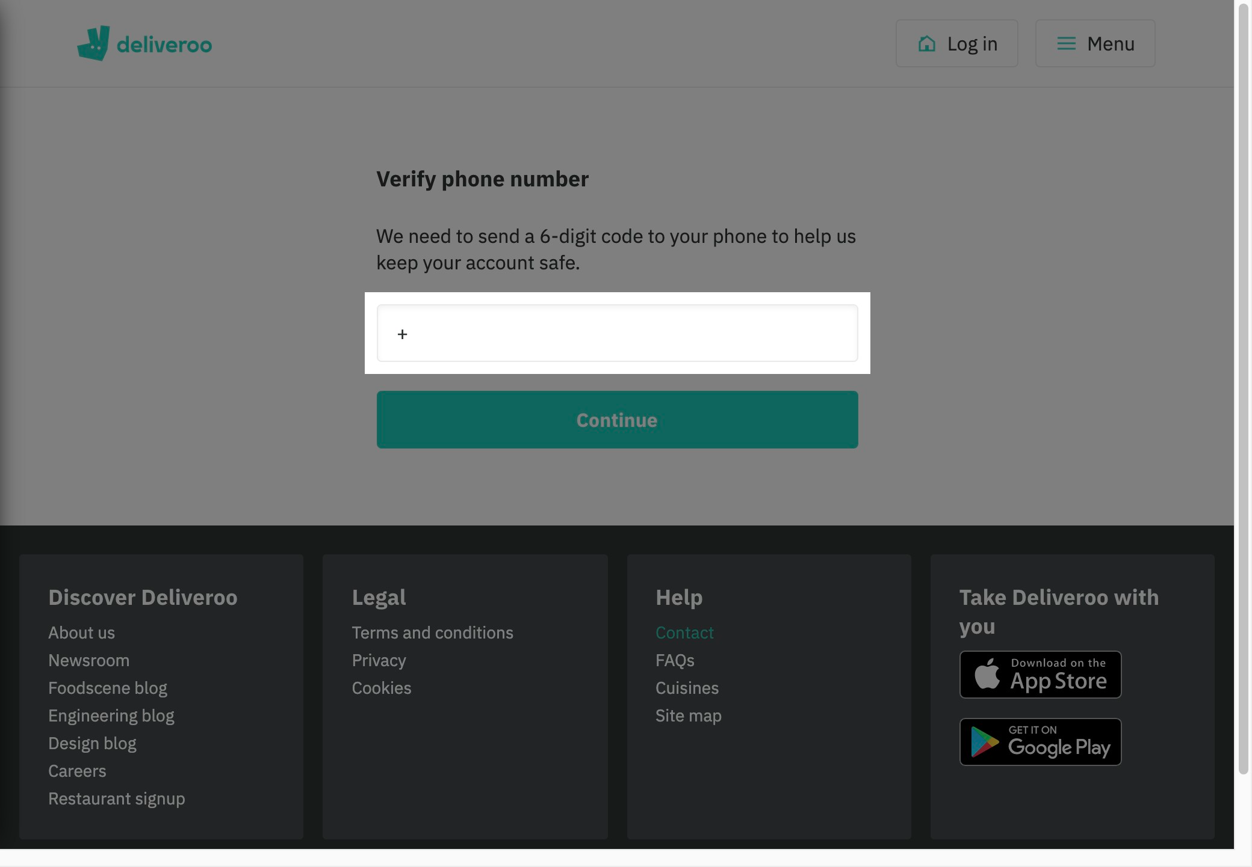

# Notes:

I am from Portugal and I was trying to create an account and until I got the phone confirmation I didn't knew that this services is not available in Portugal.

# Recommendation:

We should pick the country in the first register screen.
Flags for example.

# Heuristic: Recognition rather than recall

# Severity: 0

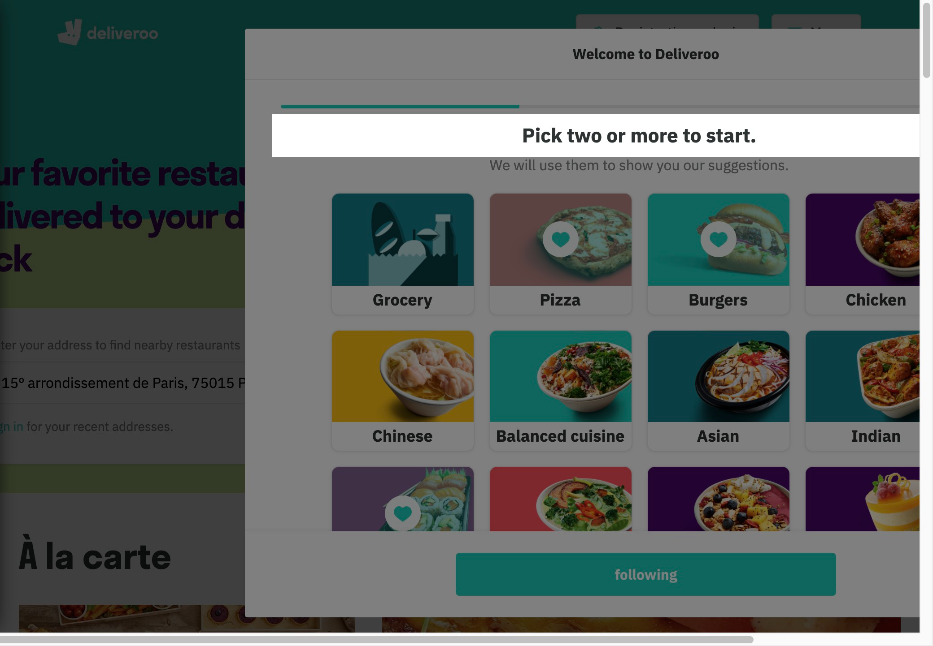

# Notes:

Picking the suggestions on this screen helps us a lot to have a quick and easy selection.

# Heuristic: Visibility of system status

# Severity: 0

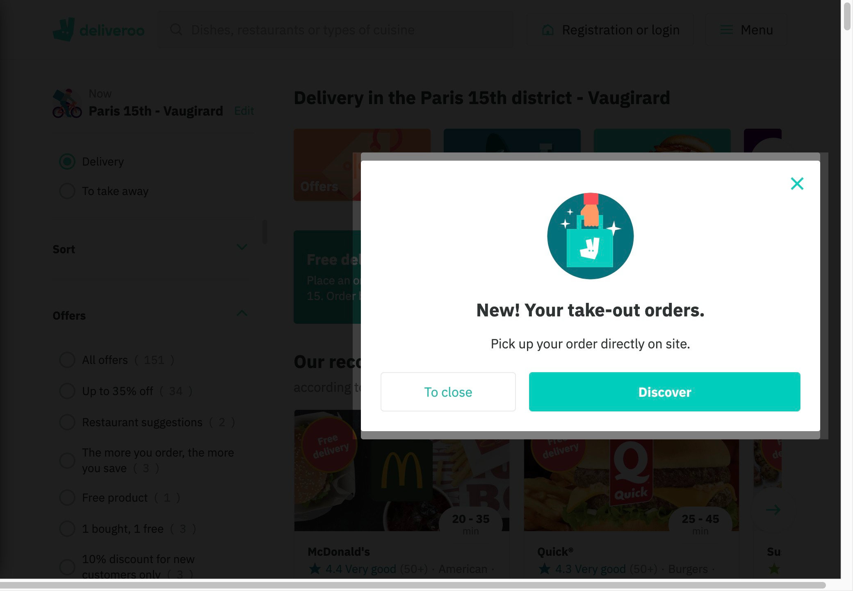

# Notes:

We are always informed about what is going on across each interaction.

# Heuristic: Help and documentation

# Severity: 0

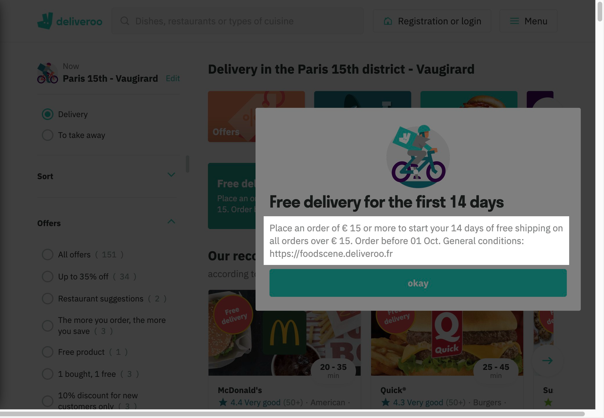

# Notes:

We are able to check the general conditions in case of any doubt about the promotion offered.

# Heuristic: Consistency and standards

# Severity: 2

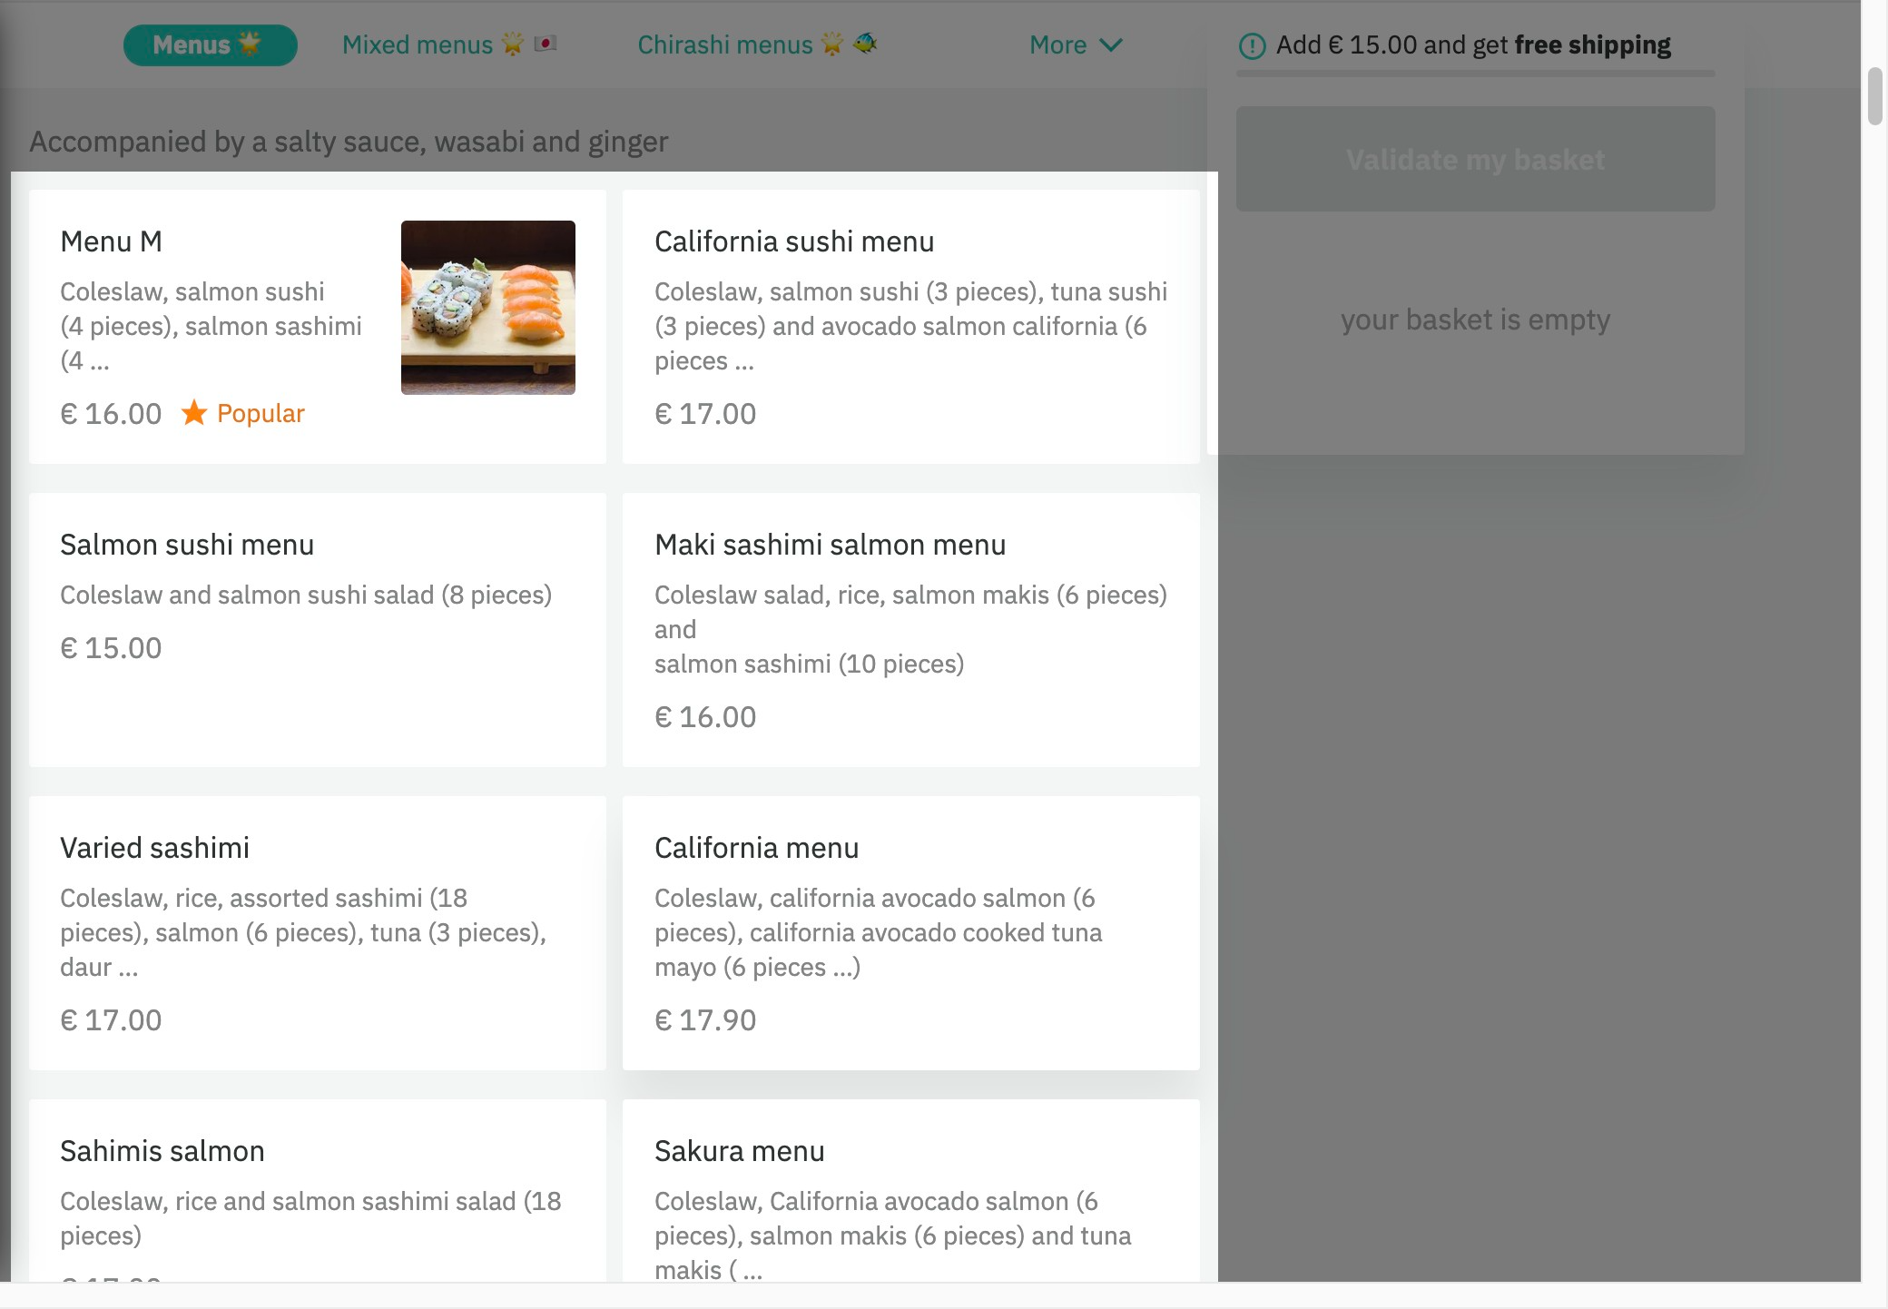

# Notes:

Not all options in the menu has a picture like the first box.

# Recommendation:

Add a picture to the other boxes

# Heuristic: Aesthetic and minimalist design

# Severity: 0

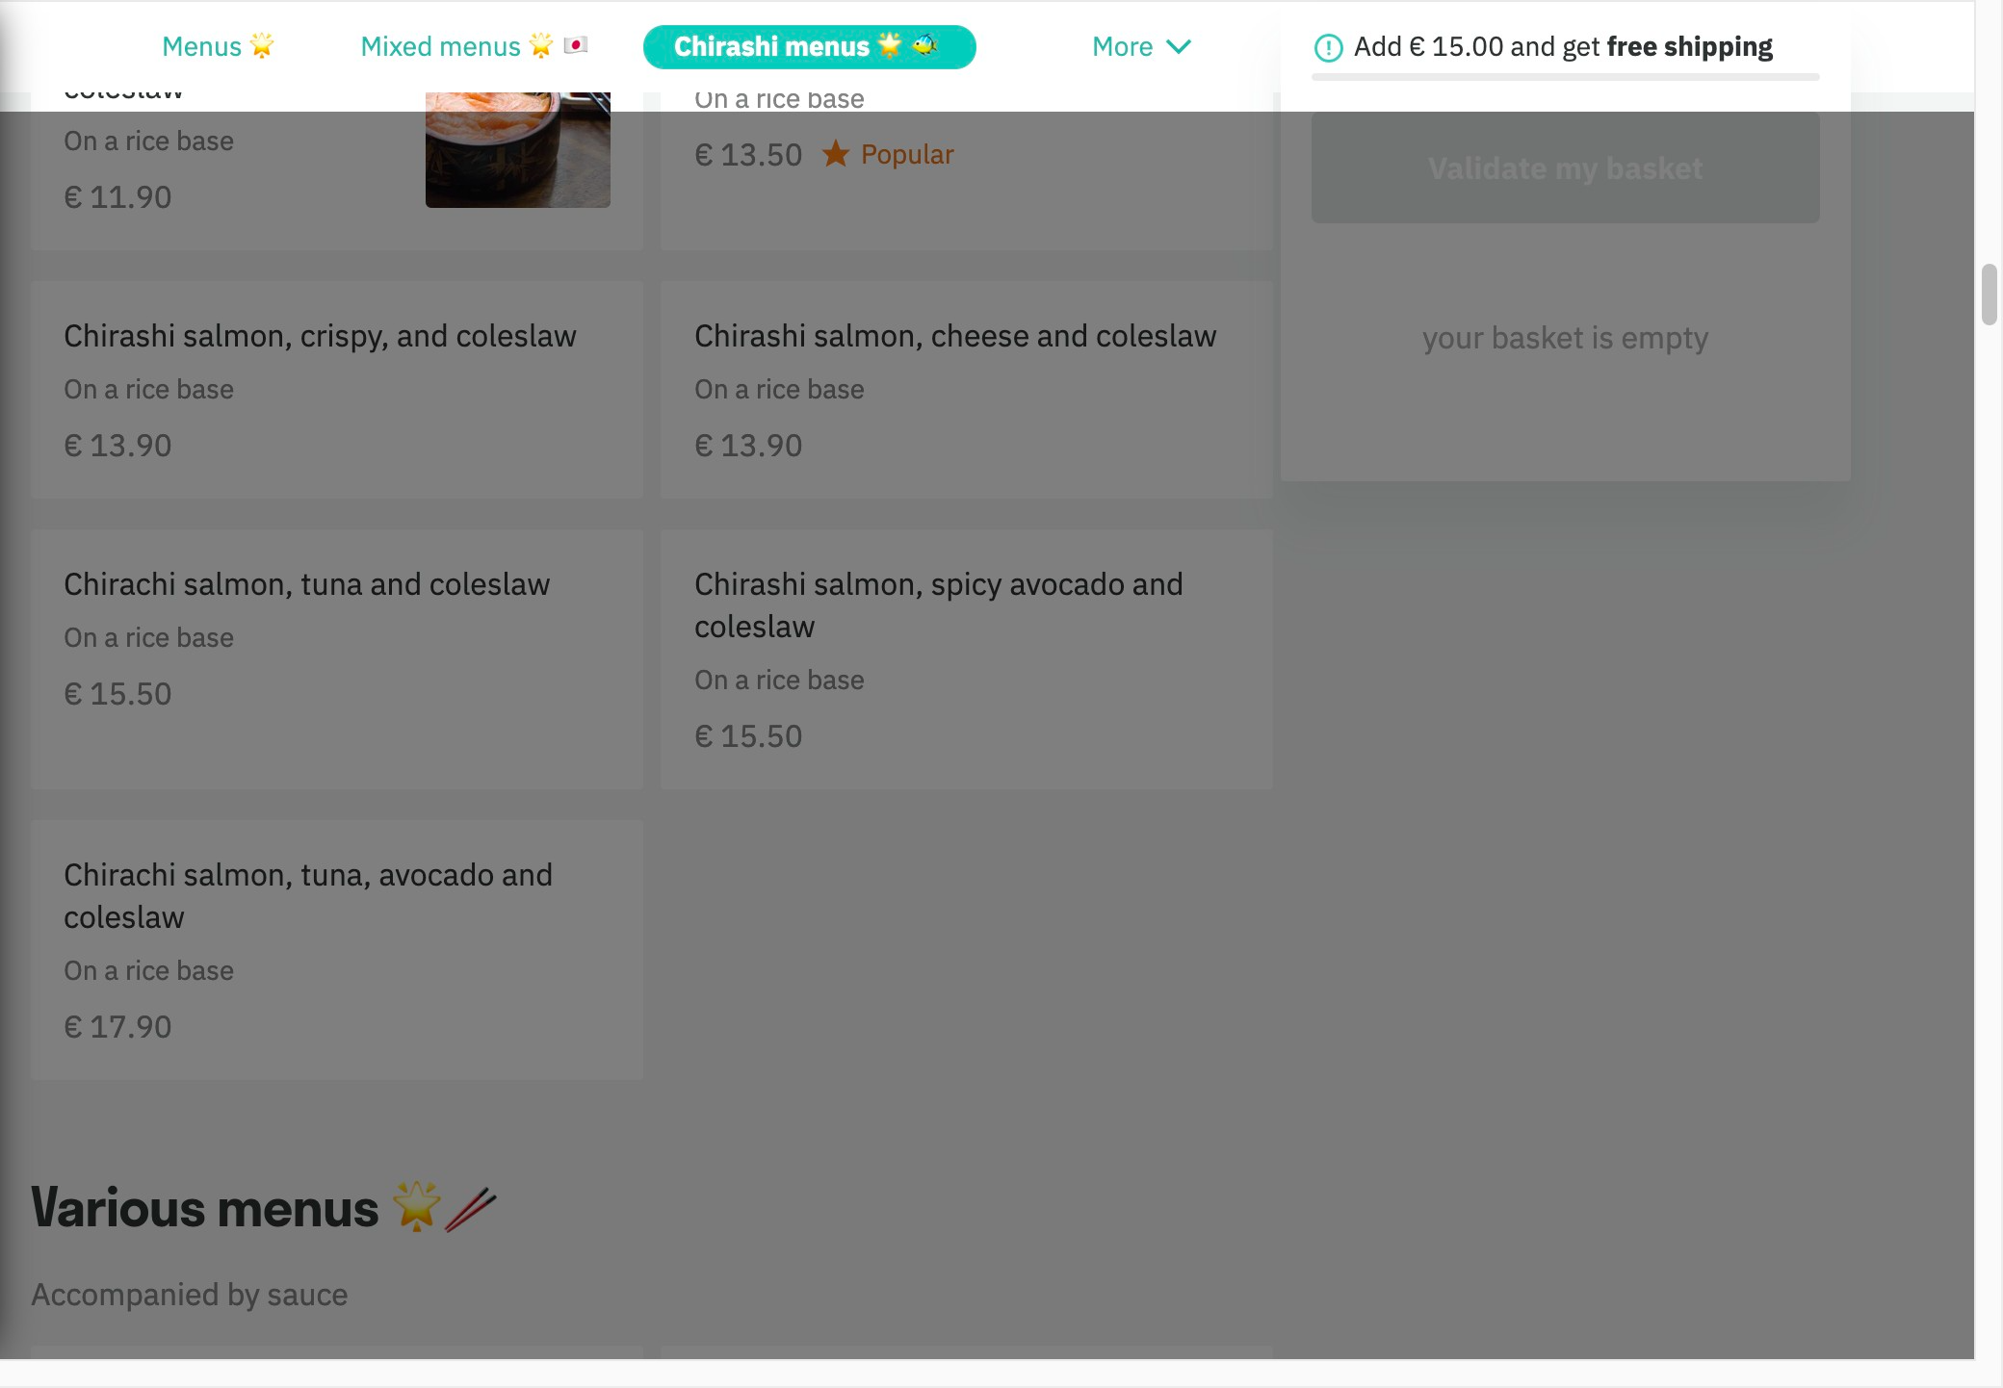

# Notes:

Easy to navigate even when the scroll down the navbar is fixed helping us to easily get other options instead of scrolling up and down.

# Heuristic: User control and freedom

# Severity: 1

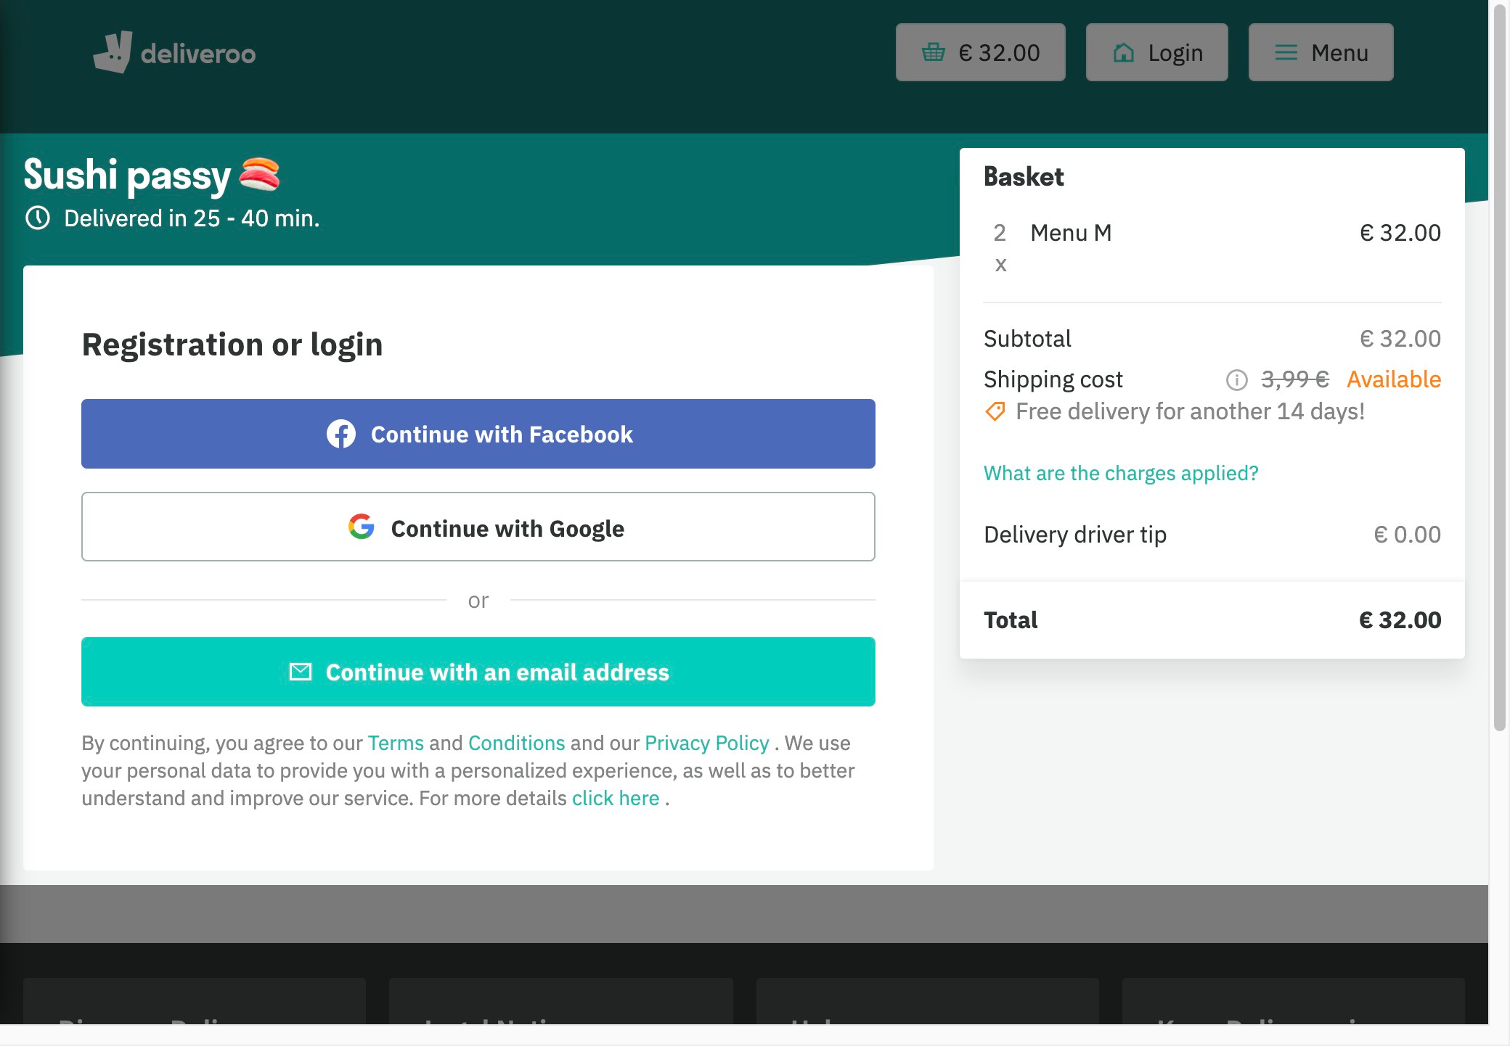

# Notes:

No back or cancel button

# Recommendation:

We should have a back button in case we need to add additional stuff but here I am not using a register account I don't know if we have that option.

# Heuristic: Visibility of system status

# Severity: 0

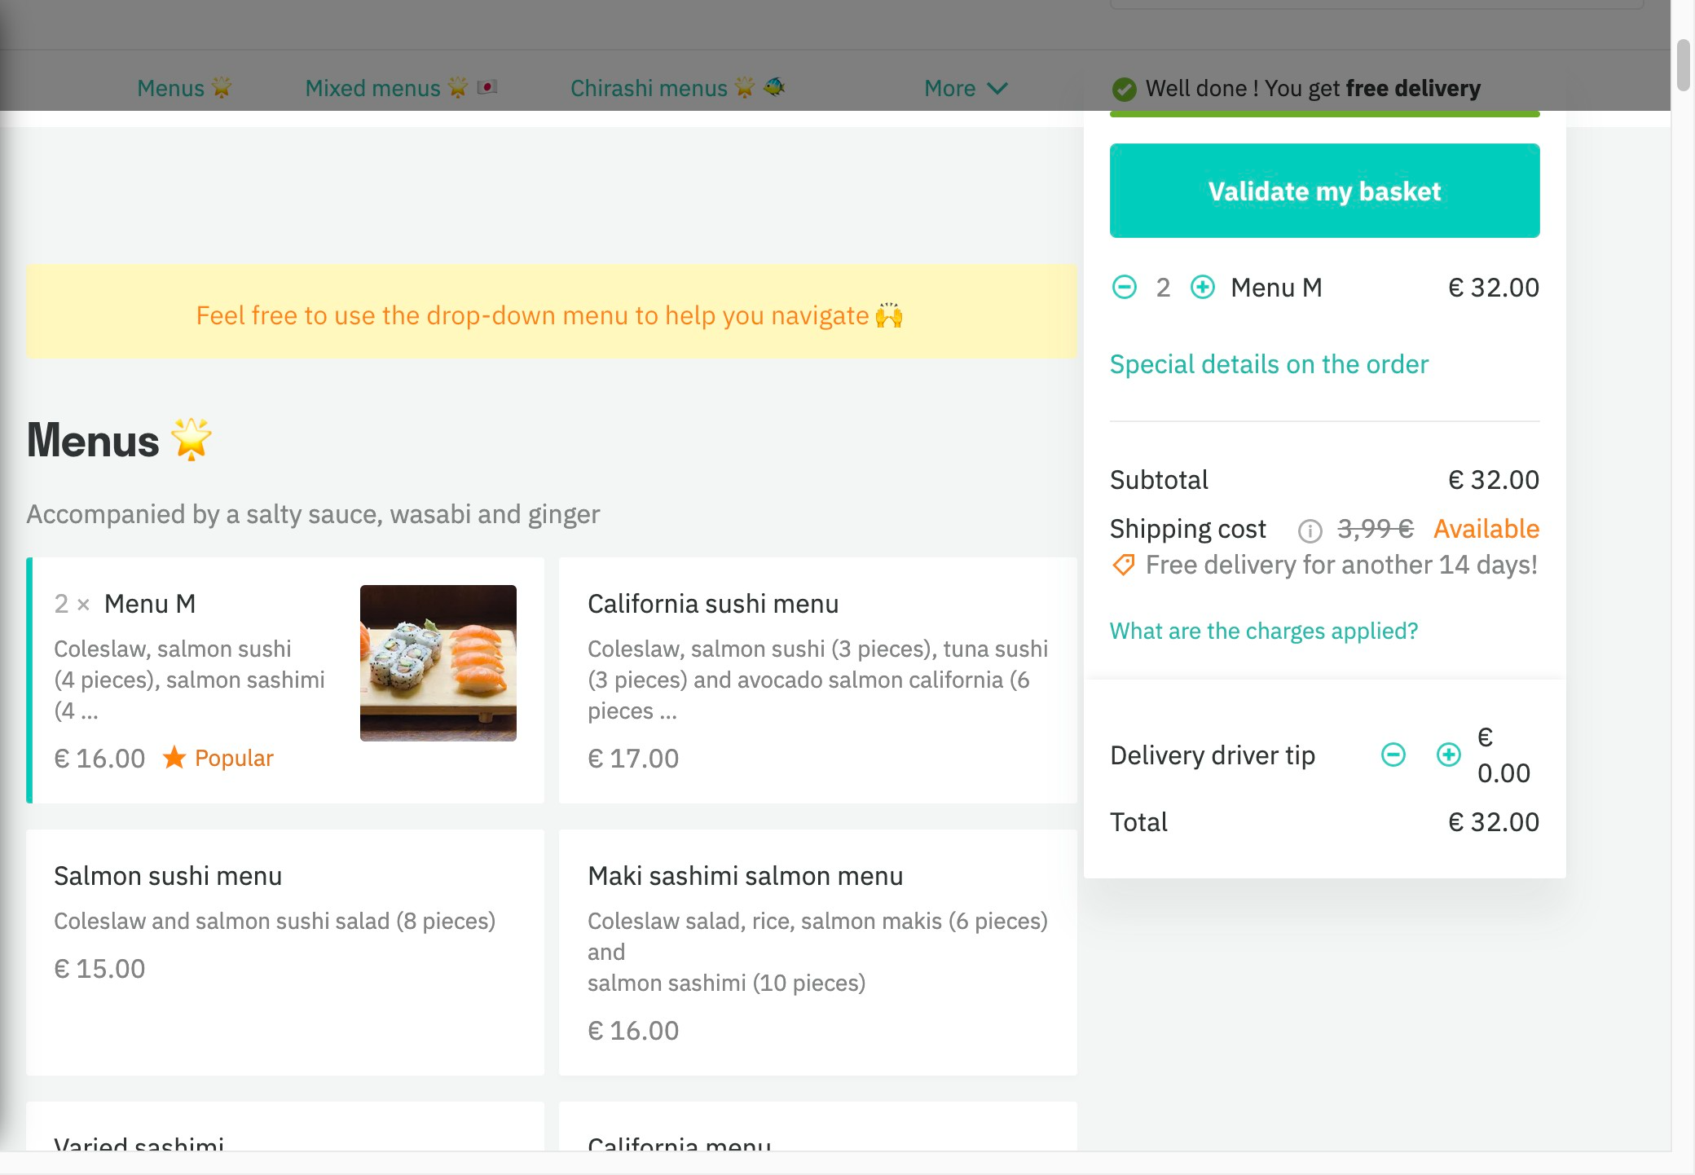

# Notes:

We have a quick way to take what we want for advance users or we have a long to chose for newbies

# Heuristic: Match between system and the real world

# Severity: 0

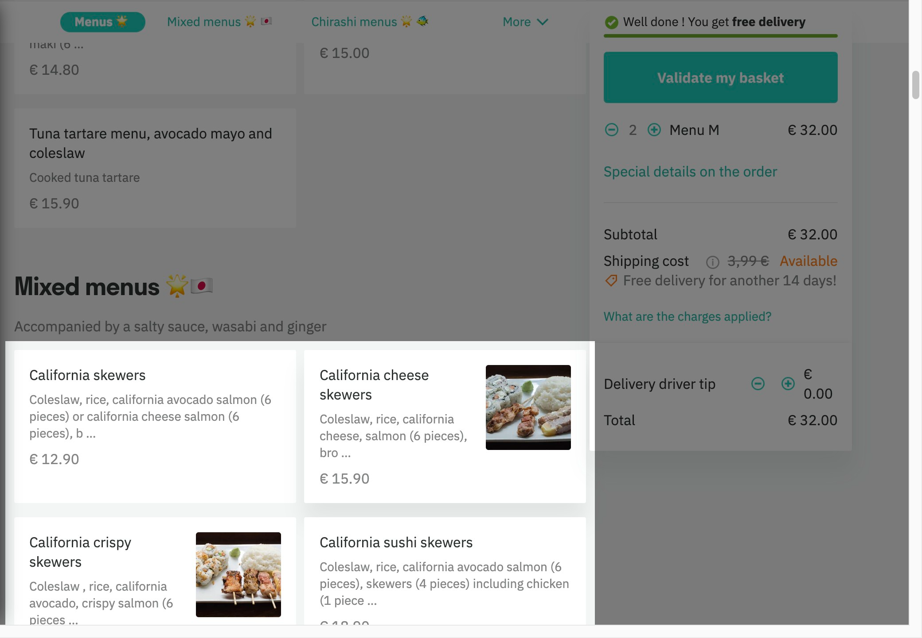

# Notes:

Clear and short description on what we should expect!
Sushi lovers language

# Heuristic: Help recognize &amp; recover from errors

# Severity: 1

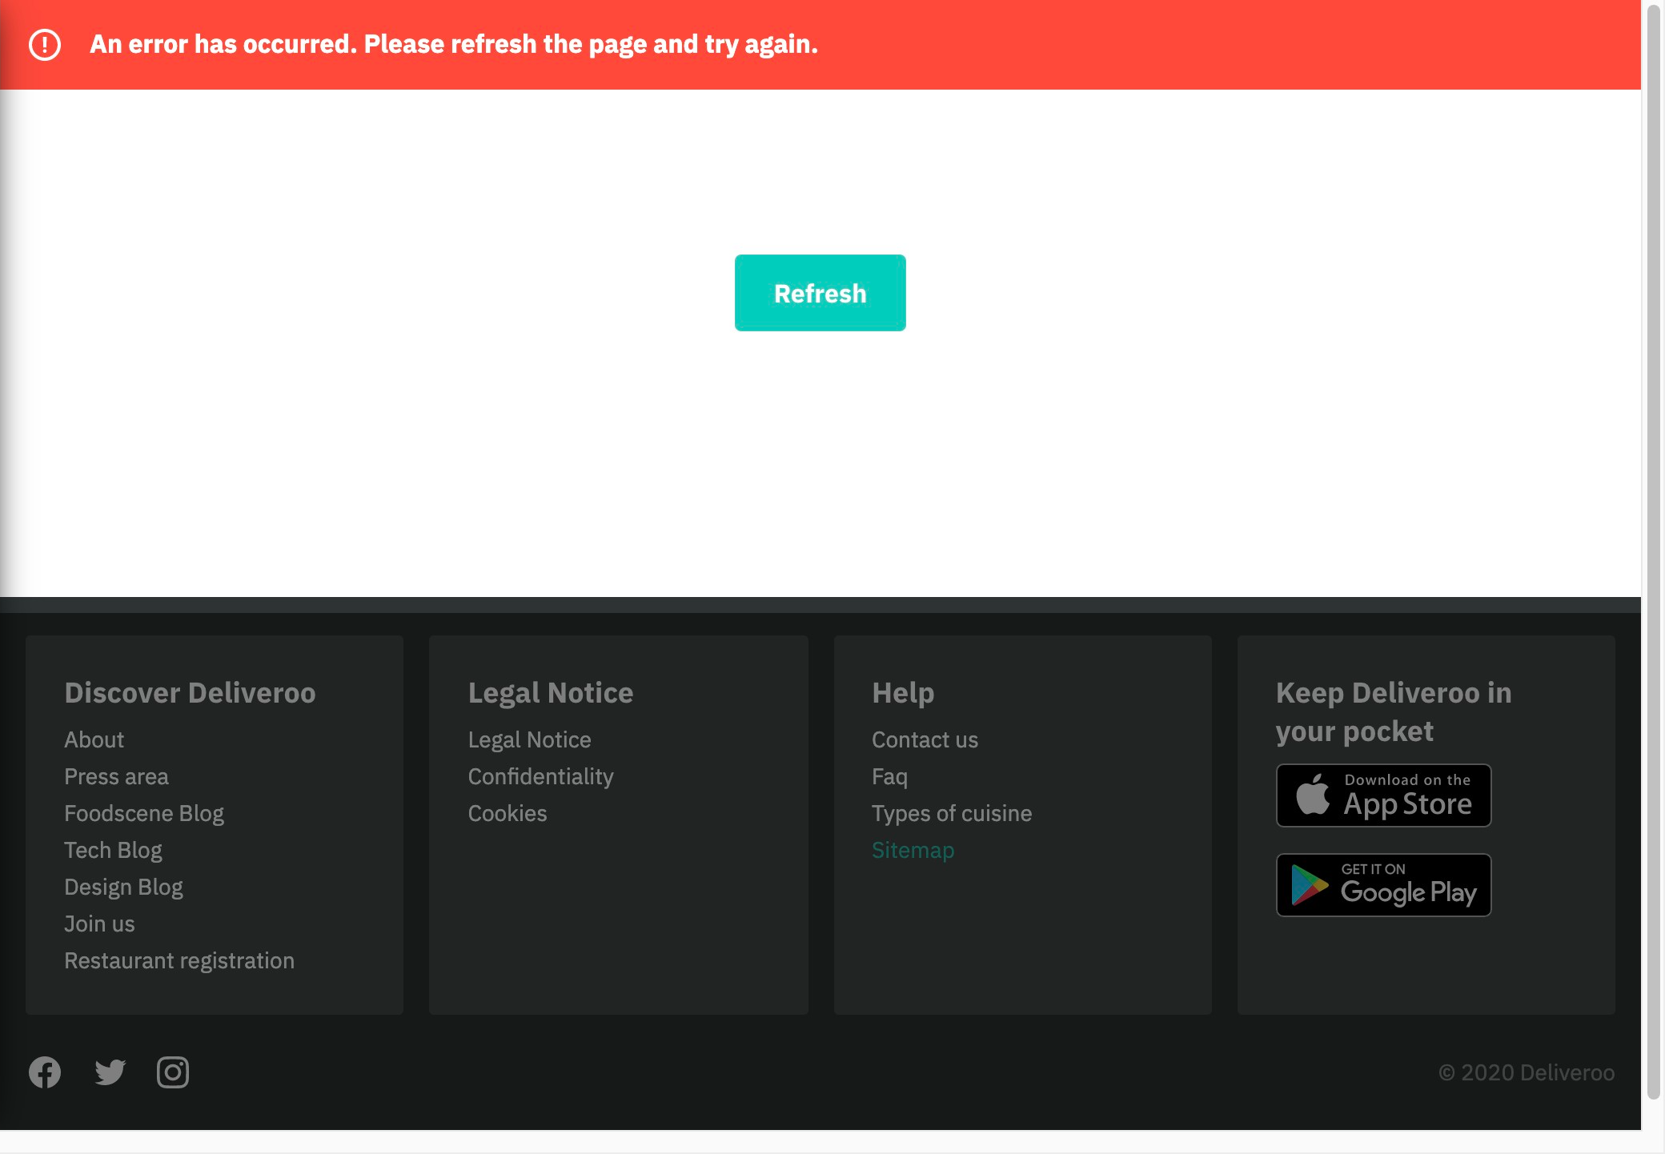

# Notes:

We are not able to understand what is the problem only have a refresh button to "solve" it.

# Recommendation:

Maybe is not any important error but if it caused by the user we should be able to know in order to avoid it in the future.